|  |  |  |  |
| --- | --- | --- | --- |
|  | **Document No.** | **Revision** | **Level** |
| FT-SW-M-20160906 | **V 1.1** | Internal |
| **Project Name：Melexis Auto-Programming Machine (For MLX91206)** | | **Total 5 Pages** |

**Software User Manual**

**(Only for Internal Use)**

**Prepare： _____________________ Date：___/___/___**

**Confirm： _____________________ Date：___/___/___**

**Approval： _____________________ Date：___/___/___**

# Software User Manual

## 1 Introduction

### Purpose

Help the user to understand the detail for the installation and requirements.

### Reference Documents

1.2.1 *MLX91206_datasheet_standard_product_rev40.pdf*, download from Melexis website.

1.2.2 *Programmierung_Melexis.docx*, get from customer.

1.2.3 *MLX91206_PSF_1.26.pdf*, get from the Melexis

### Abbreviation

None

## Software Introduction

### Function

This software is used to auto-programming the Melexis chips via PTC-04 with the proper interface, configure the proper parameters and then load into the EEPROM of chip.

### OS & Software Requirements

2.2.1 Only support **WinXP & Win7 32** bit system, not support Win10, other systems are not be tested.

2.2.2 Need install Melexis UI Module and MLX91206 Module per the *Programmierung_Melexis.docx* description in advance.

2.2.3 Need install NI LabVIEW 2013 RunTimeEngine in advance, download from NI.com. (Refer to <http://www.ni.com/download/labview-run-time-engine-2013/4059/en/)>

2.2.4 Copy the executable application file to any folder, double click it and then will run directly.

### Hardware Requirement

2.3.1 222222.3.1 40G disk, 1Gb RAM, USB interface at minimal

2.3.2 The programmer PTC-04 required registering in advance, providing the SN of PTC-04 device.

.

### UI Layout

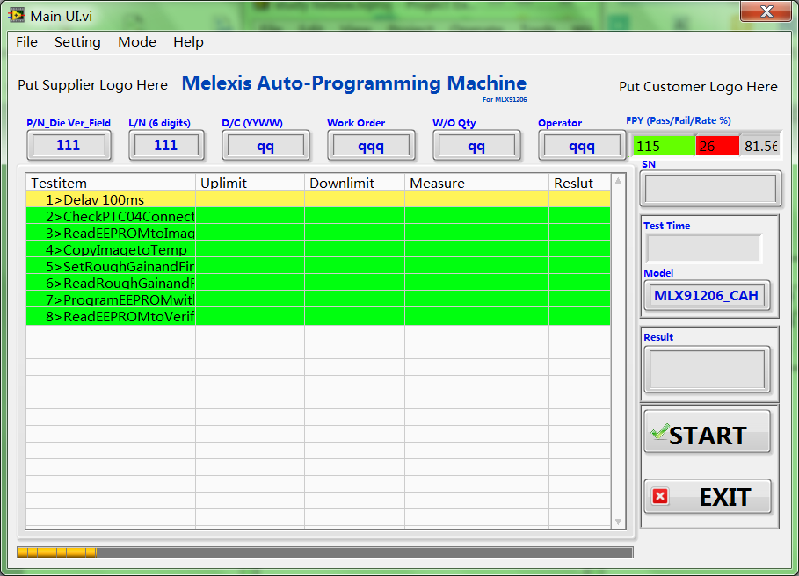

Test Items with Description, limits, respond and result.

Fig 1, Main UI

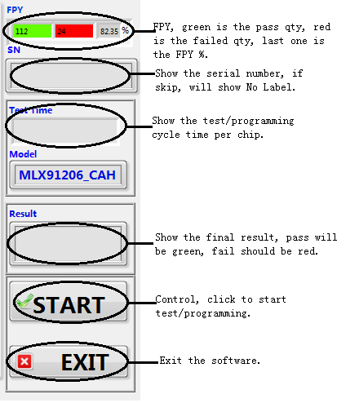

Fig 2, Controls

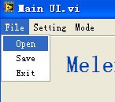 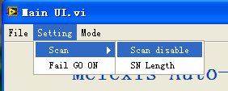 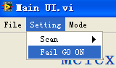 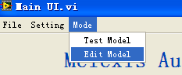 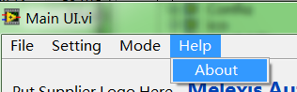

Fig 3, Menu

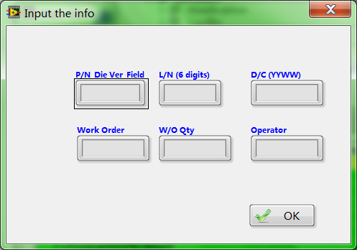

Fig 4, Load part & production information

**File-->Open**: Open a configure file, and load the parameters into the software.

**File-->Save**: Save the current configure into a new file, normally use to save the change during the **Edit Model**.

**Setting-->Scan-->Scan disable**: Disable/enable the scan function, this is a Boole switch.

**Setting-->Scan-->SN Length**: Disable/enable the check of serial number length, no application.

**Setting-->Fail GO ON**: Once failed, continue the rest steps or stop directly.

**Setting-->Login**: Enter the Fig 4, parts and production information configure page.

**Mode-->Test Model**: Default status, the Fig 1 area is not editable.

**Mode-->Edit Model**: Require the password, default is 123456, the Fig 1 area is editable. Double-click any cell, the pointed cell will be active, and change the parameter accordingly.

**Help-->About**: Revision info and technical contact window.

2.5 Test Items

2.5.1

1>,Delay 100ms: Only wait for 100ms

2>,CheckPTC04Connection: Check the connection of programmer, PTC-04.

3>,ReadEEPROMtoImage: Read the data from the EEPROM of chip to the image.

4>,CopyImagetoTemp: Copy the data from image to the temp registers.

5>,SetRoughGainandFineGain: Modify the parameters per required.

6>,ReadRoughGainandFineGain: Check and confirm the data which just modified

7>,ProgramEEPROMwithTemp: Program all data/cells into the EEPROM of chip

8>,ReadEEPROMtoVerify: Read back all data/cells from EEPROM and compare with the temp registers.

Reference document: *MLX91206_PSF_1.26.pdf*

2.6 Test Report

2.6.1 Location

C\Test Report\Lot Number\Serial number or NO label.txt

The software will create the folder automatically, but need make sure no special strings as the folder name, otherwise the software will report errors. The windows system cannot accept the” /” as the file/path name.

2.6.2 Log format,

A typical log as below (Below is only an example, not actual log), include test time; model name, and all test data with error code if fail.

Part Number_Die Version_Field: 206CAH

Lot Number: 123456

Date Code: 1644

Time: 2016-09-26 20:14:47

Model: MLX91206_CAH-004

Work Order: 1644

Operator: A1644

1>,,,,,PASS,:

2>,,,,,PASS,:

3>,,,,,PASS,:

4>,,,,,PASS,:

5>,,,,,PASS,:

6>,,,,,PASS,:

7>,,,,,PASS,:

8>,,,,,PASS,:

;;;;PASS;